Meopham Allotments

Chair’s Report Year 2018/2019
Julie Courtney

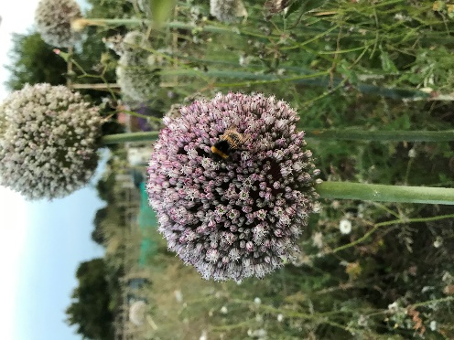
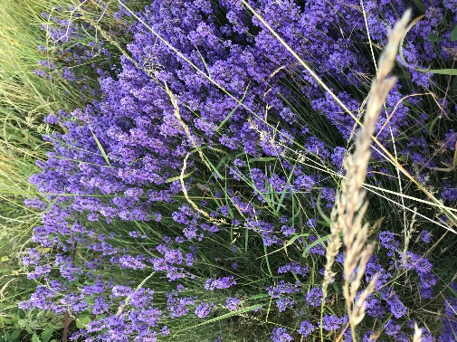
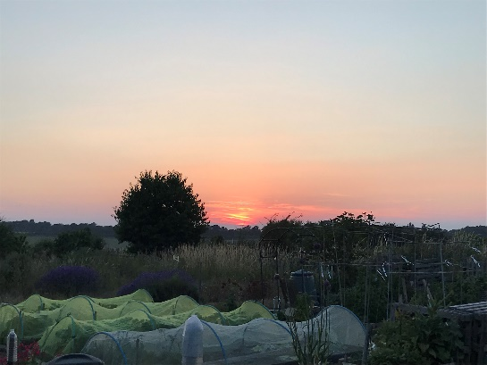
What a year it has been at Meopham Allotments, Southdown Shaw in 2018. Starting with ‘The Beast from the East’ that prolonged the start of the season for many at the allotments and then the blazing hot summer, which brought other problems, but also gave us some absolutely beautiful sunsets and crops. It has been an extremely busy and eventful year. It never ceases to amaze me what a beautiful location our allotment is in and I appreciate every minute I can get there.

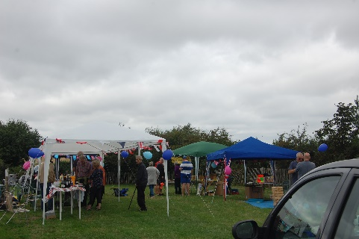
Open Day 2018
It was decided to hold the Open Day in August last year to coincide with National Allotments Week. Due to ill health and other problems, we were unsure if we would have the Open Day at all, but with only 2 weeks to organise the day, everyone got involved and made it happen.

Unfortunately during one of the warmest summers on record, the actual day of the open day was cold and windy, not the most ideal conditions for a successful open day. At one point, whilst putting up the gazebo in strong winds, there was about ten of us holding on to it for dear life and I thought we would all end up in Cobham! With the gazebos put up, balloons blown up, banners up and tea urn on, we were set up for business, just in time before the first of the visitors started rolling in.

This was an outstanding success with us letting seven out of ten vacant plots and collecting money for our nominated charity, Cancer Research UK. Not only that but we had a flying visit by Adam Holloway MP before he had to jet off to Malta on government business. He did make time to have a whistle-stop tour of the plot before enjoy the stalls, talking to the ladies from Gravesend Bee Keepers Association and buying some of their wonderful honey.

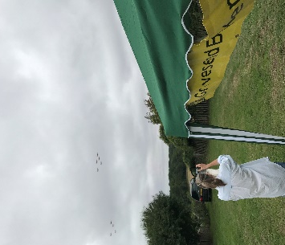
Then to top off a wonderful day we were honoured by several flybys by the Red Arrows, which was a wonderful surprise for everyone. Without the hard work of the committee and all the lovely volunteers that gave up their time, made cakes and donated items, it would not have happened, so I would like to say a huge, huge thank you to the committee and everyone who helped, drank tea and ate cakes.

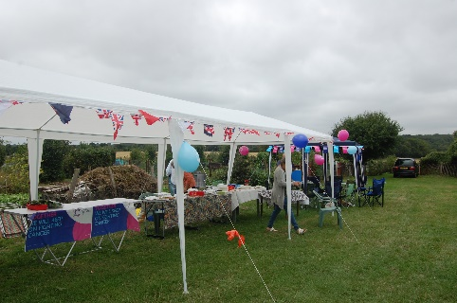

The Committee
I would just like to say a huge thank you for all the fantastic Committee members who all are volunteers, give up a great deal of their time and do an awful lot of work to keep the allotments running smoothly. The Committee have had to deal with a few contentious issues in the past year and have not all seen eye to eye at times, but are all united in doing the best for the allotment and the plot holders.

Our wonderful Secretary, Theresa, works tirelessly to ensure that things are done correctly, researching, organising and contacting people, plus looking after the Face Book page, web site, emails, and generally keeping us all in order. This is a small part of all she does and I am continually grateful for all her hard work, support she has given this year and for her never ending good humour and enthusiasm.
Our Treasurer, David, works hard ensuring that our books are kept immaculately up to date, tracking rents paid, and banking to name just a few things he does.
Our lettings officer, Peter, is another amazing member who meets up with prospective members to allocate plots and ensuring that the plots are rentable and all the other invaluable jobs he carries out.
Robin, always works extremely hard ensuring that the maintenance of the site is running smoothly, checking for water leaks, fixing the gate when needed and ensuring the roads are in good repair, to name but a few jobs.
Plus the rest of the team: Lindy, Mark and Caroline, they all do a great job, come up with some wonderful advice and suggestions and are never taken for granted. Thank you.
Plans for 2019
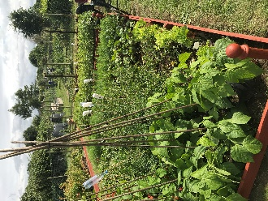
It is the Committee’s wish to hold another Open Day this year, but earlier in the year than last year so that prospective plot holders can get their plots up and running and to also hold another smaller event such as an afternoon tea. Hopefully these events will be as successful as last years and enjoyed by all.
We are also hoping to hold some more social events, such as monthly coffee mornings and quizzes and would love as many plot holders as possible to get involved.
I wish all our plot holders a wonderful growing season and success in such a wonderful location as Meopham Allotments, Southdown Shaw and look forward to seeing all your lovely photos and hearing all your success stories in 2019. Happy growing.

Julie Courtney
