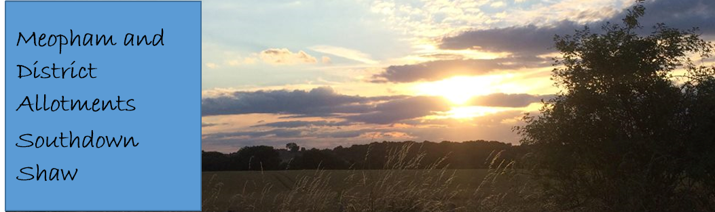Keeping chickens on allotments
It doesn’t matter if you decide to keep them as pets or for a supply of fresh eggs, keeping chickens is a serious matter and should only be done if you have the time and resources to look after them properly.
Despite their appearance and actions, hens are quite intelligent and naturally inquisitive, and like to look around, exploring their surroundings and scratching at the soil to see what they can unearth. They can get frustrated and bored if their surroundings are not well kept, which can lead to them fighting or becoming ill.

Hen houses and nesting boxes
All hens must be able to stand, turn around and stretch their wings when inside. They also need enough space to perch or sit down without interference from other birds, when they are all together inside the hen hut or in their outside space.
The hen house must be warm, dry, well ventilated and above all, secure. Although enough fresh air should be provided by means of doors or other apertures, the birds should be protected from draughts, and it is recommended that the entry doors face due south wherever possible.
The floor inside the hut should be easy to keep clean, as the floor coverings (wood shavings or straw) will need to be topped-up or replaced when needed. This is especially important when it’s wet, as the floor coverings are used for foraging and dust bathing.
Perches should be around 3 to 5 cm wide with rounded edges (like a brush handle), and at the right height to suit the size of the bird. Hens like to perch and sleep together at night, so there should be enough room inside the hen house for all the birds to roost at the same time. At least 15 cm should be allowed for each bird, with enough room between the perches so that they can get up and down without hurting themselves.
All birds need peace and quiet to lay their eggs, and they will look around and investigate a number of places before settling down to lay. The nest boxes themselves should be draught-free, quiet and enclosed with a good layer of clean dry nesting material of straw or wood shavings.
The huts require regular cleaning and disinfecting and all litter etc. needs to be disposed of in secure containers. Nest boxes, roosting areas and perches must be properly and securely located inside the huts.

Outside areas
Hens must have continuous daytime access to open air runs, which should be moved regularly to avoid ‘fowl sick’ or muddy conditions that could lead to ill health or discomfort. These exercise areas can be provided with wire fenced runs.
It is most important that all the birds have access to an outside exercise area during hot weather, or when it is warm and humid. There should be overhead cover, such as small trees or a purpose built shelter which will give the hens protection not only from the sun but also from bad weather and any possible predators.
The hens should be able to access the shelter at all times, except when the huts are being cleaned and disinfected. All exercise runs shall be escape and predator proof.

Health
A healthy bird will be alert and interested in her surroundings, have clear bright eyes, a good posture and will move quickly if startled, while regular dust baths will help keep their skin, legs and feet clean and healthy. Hens must have access to a minimum of 8 hours daylight during any day which is adequate to inspect all birds on the site.
Parasites, lice and red mites can be frequent problems, and the hens should be checked regularly for infestations. The hut should be tall enough to let the keeper to stand and inspect the birds while inside.
As well as inspecting and treating the birds, the hen house and nest boxes should also be cleaned and disinfected regularly to remove parasites etc from crooks and crevices. Regular worming will also be needed, especially if the hens are not moved about onto fresh grass but are kept in the same runs for more than a month at a time.
The early signs of ill health may include changes in food and water intake, in preening, in 'chatter' and in activity. There may also be a drop in egg production and changes in egg quality such as shell defects.

Feeding and watering
Clean fresh water must be available at all times, and food and water containers should be kept clean and in good condition. Hen feed should be stored in vermin proof containers, and must be properly balanced for the type hens kept. Enough food should be given to ensure the hens are properly fed but not too much, as uneaten food left on the ground will attract vermin. The hens should be visited at least twice a day, to ensure they have enough to eat and to make sure that drinking water does not freeze during winter months.

Fire precautions
All inflammable materials such as straw, waste litter and empty bags must be stored well away from the hen huts and exercise areas and something for controlling small fires such as dry sand should be kept close by in case of emergencies.

Frequency of inspection
All birds must be inspected at least twice daily. The tenant must allow the Allotment Officer and/or an animal welfare representative to inspect the poultry at any time. Anyone who keeps hens on their allotment must make sure they can be contacted by the Allotments office in case of emergencies.

Disease control
Any sick or injured birds must be removed immediately and the correct and appropriate treatment provided. The cause of any disease or injury will be identified and remedial action taken. Any national disease prevention and/or control programmes must be adhered to.

Cleansing and disinfection
The hen hut, runs and exercise area should be regularly cleaned and disinfected. If possible, it is advisable to move the hut and runs every couple of months onto fresh grass. Only clean, fresh good quality bedding materials should be used.

