Links to recipes online:
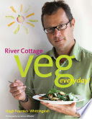

RIVER COTTAGE VEG EVERY DAY
Suggested by Bella Dawkins Gosling

https://books.google.co.uk/books?id=a6f3S-w5_eoC&pg=PT599&lpg=PT599&dq=river+cottage+beetroot+tea+loaf&source=bl&ots=NHGV4EVPUU&sig=LzFJE2O_h-KHF79BJXF13tuKsmQ&hl=en&sa=X&ved=0ahUKEwiUqb_ujbzPAhVHIsAKHdfMB00Q6AEINjAI#v=onepage&q=river%20cottage%20beetroot%20tea%20loaf&f=false

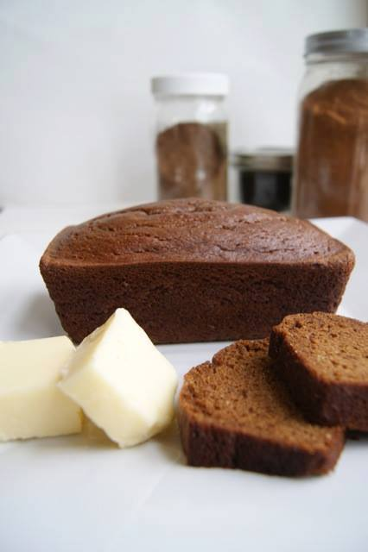

GLUTEN/DAIRY/SUGAR FREE & DELICIOUS
Suggested by Maggi Martin

http://elanaspantry.com/

