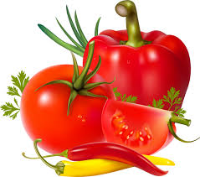

Roasted Tomato and Red Pepper Soup.

Ingredients:

2 Red Peppers
6-8 Tomatoes
3-4 Garlic Cloves (optional)
4 Small Red Onions
2 Carrots
1 Stick of Celery
300ml Vegetable Stock
Chilli (optional)
Salt and Pepper

Method:

Cut the peppers, tomatoes and onions into rough chunks chop the carrots and celery into smallish pieces and crush the garlic. Place in lightly oiled roasting tin and roast at 200C for 40 minutes, stirring halfway through. Blitz and pass through a sieve. Add the Vegetable stock and bring back to the simmer, then add chilli, salt and pepper to taste.

